Hydroponic

Background
- Hydroponics is a way to skip the soil and grow crops directly in nutrient-rich water.
- Roots are submerged in an inorganic medium then apply nutrient rich water
- Examples of inorganic mediums are vermiculite, pearlite, rockwool or expanded clay substrate

Benefits
- Reduces the amount of water required for plants
- Reduces issues that many soil-based greenhouses experience such as bacteria growth, mould and pests.
- Massively increases growth rate of most plants
- Increases production yield

Types
- There are six main types of hydroponic systems to choose from:
  - Wick Systems
  - Deep Water Culture (DWC)
  - Nutrient Film Technique (NFT).
  - Ebb and Flow (Flood and Drain)
  - Aeroponics
  - Drip Systems
  - Kratky Method

Wicking Systems
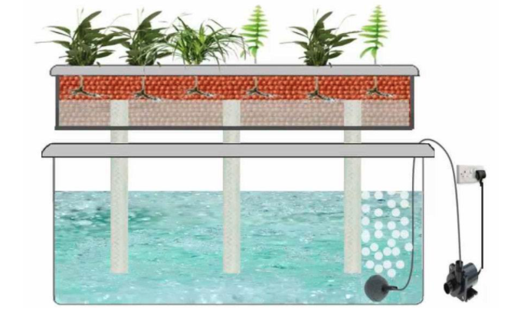
- Also known as passive hydroponics
- Do not need air pump or water pump
- Nutrients and water are moved into a plant’s root zone via a wick, which is often something as simple as a rope or piece of felt.
- Key to success in this system is the medium
- Good choices include coconut coir, perlite, or vermiculite
- Pros
  - Good for smaller plants
  - Truly “hands off” if set it up correctly
  - Good for children and beginner
- Cons
  - Larger plants may have problem with getting enough nutrients and water
  - Incorrect wick placement or material can mean death for your plants

Deep Water Culture (DWC) Systems
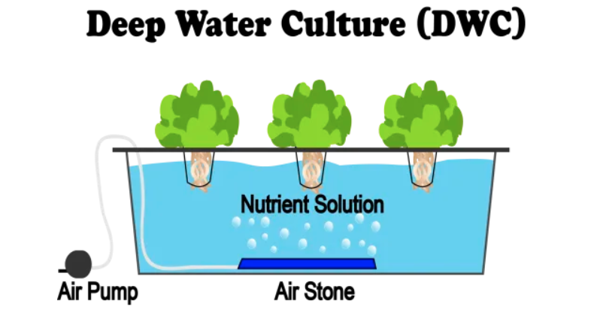
- Use reservoir to hold nutrient
- The roots of the plants are suspended in that solution, so they get a constant supply of water, oxygen, and nutrients.
- To oxygenate the water, use an air pump with an air stone to pump bubbles into the nutrient solution. This prevents roots from drowning in the water
- Plants are typically housed in net pots that are placed in a foam board or into the top of the container
- Pros
  - Very inexpensive and easy to make at home
  - Extremely low maintenance
  - Recirculating, so less wasted inputs
- Cons
  - Does not work well for large plants
  - Does not work well for plants with long growing period

Nutrient Film Technique (NFT) Systems
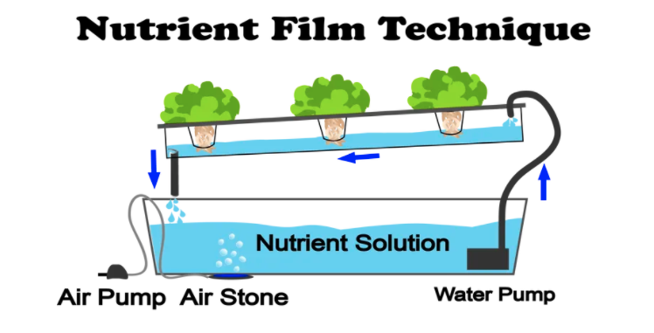
- Is a popular hydroponic system
- Plants are grown in channels that have a nutrient solution pumping through them and constantly running along the bottom of the channel.
- When the solution reaches the end of the channel, it drops back into a main reservoir and is sent back to the beginning of the system again. This makes it a recirculating system, just like deep water culture.
- Unlike deep water culture, plants roots are not completely submerged
- Plants are placed in these channels using net pots and growing medium and can be replaced or harvested on a one-by-one basis.
- Pros
  - Minimal growing medium needed
  - Recirculating system means less waste
- Cons
  - Pump failure of any kind can completely ruin the crop
  - Roots can become overgrown and clog the channels

Ebb and Flow / Flood and Drain Systems
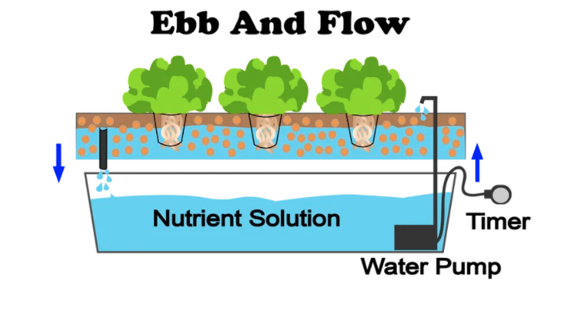
- Does not expose the roots of the plants to nutrient solution on a constant basis
- Instead, it is grown in a tray filled with a growing medium.
- The tray is “flooded” with your nutrient solution a few times per day, depending on factors like:
  - The size of the plants
  - The water requirement of your plants
  - The air temperature
  - Where the plants are in their growth cycle
- Accomplished by using a reservoir below the tray, a water pump, and a timer to schedule the flooding cycle.
- After the tray is flooded, gravity drains the solution back down into the reservoir, where it is being oxygenated by an air pump and air stone. It sits there waiting for the next flood cycle, and the process goes on.
- Pros
  - Efficient use of water and energy
  - Highly customizable and flexible
- Cons
  - Roots can dry out quickly if environmental conditions are off or the pump or timer fails
  - Uses a lot of growing mediums

Aeroponics Systems
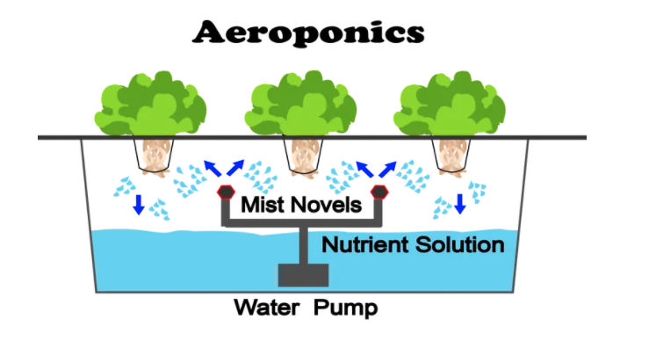
- Similar to a NFT system in that the roots are mostly suspended in air
- Difference is that an aeroponic system achieves this by misting the root zone with a nutrient solution constantly instead of running a thin film of nutrient solution along a channel
- Mist on a cycle like an ebb and flow system, but the cycle is much shorter, typically only waiting a few minutes between each misting.
- Also possible to mist on a continual basis and use a finer sprayer to ensure more oxygen gets to the root zone
- Aeroponic systems have been shown to grow plants even quicker than some of the simpler systems like deep water culture, but this has not been verified to be true in all cases
- Pros
  - Roots often are exposed to more oxygen than submerged-root systems
  - High-pressure nozzles can fail and roots can dry out
- Cons
  - Not as cheap or easy to set up as other methods

Drip Systems
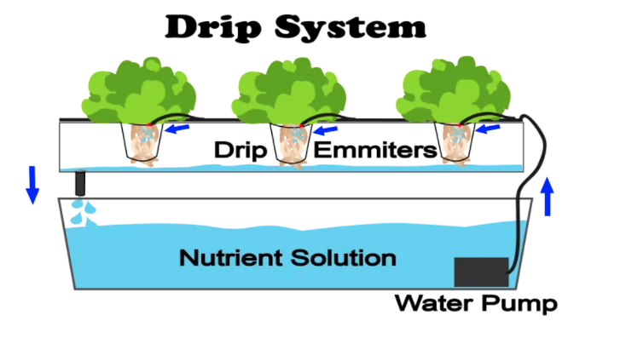
- Extremely common in commercial operations, but less common in recreational gardens.
- Simple to operate on a large scale, but slightly overkill for a smaller garden.
- Water is pumped in tubing that can end at a single plant or can branch off with several tubes ending at many plants
- Usually set on a timer
- Nutrient rich water flows over the grow medium and drips down over the plant roots
- Can be set up as either recover or a non drip recovery method
- Non recovery systems
  - Nutrient water that runs over the plant’s roots does not go back into a reservoir
  - It’s only used once
- Recovery systems
  - Reuse the nutrient solution after it’s dripped over the roots
  - More efficient in saving money, water and nutrient solution
- Pros
  - High level of control over feeding and watering schedule
  - Less likely to break
  - Relatively cheap
- Cons
  - May be overkill for a smaller garden
  - Fluctuating pH and nutrient levels (if using recirculating system)
  - High waste (if using waste system)

Kratky Method
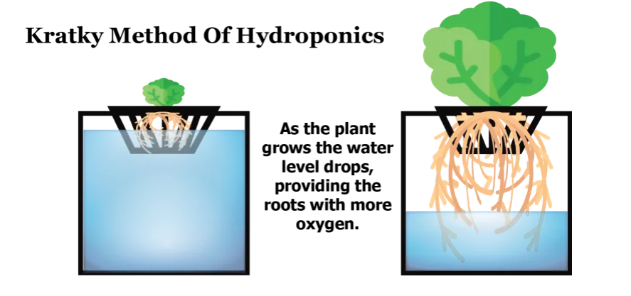
- Entirely passive
- No pumps required
- The nutrient solution remains stagnant
- As the plants drink from their small reservoir and the water level drops, an air gap grows between the nutrient solution and the plant itself, allowing the plant to breathe without oxygenating the reservoir.
- When more water is added into the reservoir, it is important to leave an unfilled area open for the roots to breathe
- Works better indoor or in a greenhouse or covered area
- Pros
  - No electricity needed
  - Minimal maintenance
  - Minimal cost
- Cons
  - Harder to control when the system is outdoor due to rain water may flood the system and dilute nutrient solution
  - Larger plant grows slower
  - May have pests problem due to stagnant water
  - Need quality water to start (be aware of the salt and the pH)
  - Harder to control temperature

Important of pH Level
- The best pH for hydroponics is a slightly acidic range of 5.5-6.5. However, it does vary from plant to plant
- Availability of nutrients vary with pH

Source
https://www.epicgardening.com/hydroponic-systems/
https://www.nosoilsolutions.com/nutrient-film-technique-nft-hydroponics/
https://www.nosoilsolutions.com/deep-water-culture-hydroponics/
https://www.gardeningchores.com/types-of-hydroponic-systems/
https://www.nosoilsolutions.com/6-different-types-hydroponic-systems/
https://www.nosoilsolutions.com/aeroponics/
https://www.nosoilsolutions.com/drip-hydroponics/
https://www.nosoilsolutions.com/kratky-method-hydroponic-gardening/
https://smartgardenguide.com/best-ph-for-hydroponics/
https://www.youtube.com/watch?v=iLTLGlMm5as
https://www.youtube.com/watch?v=dC5mPpFs32Y

Composting

What is composting?
- Natural process of decomposition and recycling of organic material into humus (a rich soil additive)

Benefits of Composting
- Decreases municipal collection and disposal cost
  - Decreases the amount of garbage → decrease curb side garbage collection → less collection required → decreases cost
- Prolong the life of landfill
  - Landfills are designed to keep air and moisture out, which are necessary for decomposition. Methane gas and leachate are produced when organics break down under these conditions, so putting less organic waste into the household trash
- Improves soil quality and plant health by:
  - Retains moisture
  - Prevents erosion
  - Replenish nutrients in soil
- Reduces the need to water gardens
- Eliminates the need to purchase other fertilizers
- It is FREE

What Can Be Composted?

Nitrogen Rich Source (“Greens”)
- Kitchen scraps such as:
  - Fruit & vegetable peels and cores
  - Egg shells
  - Coffee grounds & filters
  - Tea bags
  - Flowers

Carbon Rich Source (“Browns”)
- Yard waste such as:
  - Dried leaves
  - Wood chips or shavings
  - Straw
  - Dried cut grass
  - Weeds before they go to seed

Important Information
- The ratio between carbon source and nitrogen source is the key to successful composting
- The ideal C/N ratio 2 greens : 1 browns
- The smaller the particles, the quicker it is to break down

Do Not Compost
- Meat
- Bones
- Dairy products
- Cooking oil
- Invasive plants (e.g. Himalayan balsam, Japanese knotweed)
- Human or pet wastes
- Charcoal or coal ashes

Setup
- Composting can take place in a bin or a pile. Bins help keep the compost neatly contained and can keep animals and pests out.
  - Can purchase a composting bin or build one from wood or wire mesh.
- The best place for the composter is in a convenient, sunny location on level ground with adequate drainage.
- Place a layer of sticks at the bottom of the composter to keep the pile aerated. Place 5 or 6 centimeters of small branches or twigs at the bottom of the composter and make a hole in the center (like a nest)
- Put a layer of dead leaves, compost or earth. Preparing the bottom of the composter will allow for better aeration, stabilize humidity and prevent decomposing matter from compacting into the ground.
- Then alternate layers between browns and greens. Avoid adding thick layers of any one type of waste.
- New materials should be placed in the center, which is the most active area of the pile, while partially decomposed materials should go on the outer edges of the pile.
- The process requires moisture and oxygen, so it is important to keep the pile moist and turn it regularly with a shovel or pitchfork.
- For finished composter sooner, stir it as often as every 3 to 5 days. Otherwise, turning every couple of weeks in warm weather will be sufficient

Mix and Maintain

Compost needs air
- Every 2-3 weeks, before adding new material, mix the pile with a compost turner, pitchfork, or other garden tool.
- Garden stakes, pipes, or even simple holes poked with a broom handle can also help allow air into the pile.
- An unmixed pile will compost very slowly and may create an unpleasant smell.
- If aeration is not properly achieved, the materials will rot and start to smell

Compost needs water.
- Humidity is key to bacteria development
- Keep the pile about as moist as a well-wrung sponge.
- Don’t forget to try to recycle and use harvested rainwater or leftover (non-dairy!) beverages.

Using Finished Compost
- Following instructions can produce finished compost in as little as 6 months.
- Without adding the proper ratios or turning the pile, the process can take up to 2 years.
- Finished compost should feel like a wrung-out sponge. When squeeze a handful of it, no more a couple drops of liquid should come out.
- It should be a dark brown colour and should have a pleasant earthy smell to it.
- Wait until the pile is fully inactive before using the compost. The microbial activity generates heat, so when finished, the centre of the pile should no longer feel hot.
- Can also screen out larger items that have not broken down (twigs, etc.), return them to the pile, and spread finished compost onto the lawn as a top dressing, no more than 1cm deep.
- Finished compost can be used in many ways:
  - High in nutrients, it can be applied as desired to gardens, houseplants, hedges, and bushes.
    - Mix finished compost with garden soil to use in a flower or vegetable garden, no more than 8cm deep.
  - You may wish to screen or sift your compost through wire mesh. Sifted compost can be used as potting mix and for starting seeds and plants. Sifted compost is also an excellent top dressing for lawns.
  - The woody leftovers or un-composted materials can be used as mulch or composted again.

Troubleshooting

If too dry
i.e Dust appears when turned, it does not stick together when squeezed a handful
- Add water or leave the lid open when it rains

If too wet
- Add carbon-rich (“browns”) to absorb moisture

Odours

Possible Causes
- Not enough air
- Too wet
- Too compacted
- Too many “greens”
- Too much food waste

Possible Solutions
- Mix in dry browns.
- Turn the compost to add air.
- Add some untreated wood ashes, sawdust, or shredded newspaper.
- If drainage is a problem, building a plank floor can help.
- If it smells like rotten eggs, turn the pile for several consecutive days until the smell is gone, and top the pile with soil or finished compost.
- When adding new material, make a hole in the top of the pile, stir in the organics, and cover with dry ingredients such as leaves. Always try to have a layer of browns on top of the pile
- Can also add soil at any stage of the layering process. A thin layer of soil added on the top of the pile also helps to discourage pests and prevent odours

Animals/pest prevention
- While critters like worms, centipedes, and other insects should appear in the composter to help the bacteria break down the material, these actions will help make the pile less appealing to animals and prevent flies.

Possible Causes
- Food residuals exposed
- Bin unprotected

Possible Solutions
- Ensure the lid is closed and locked after adding and mixing materials
- Always completely cover food residuals with a layer of browns, soil, or finished compost
- Ensure that fats, oils, meats, seafood and dairy are excluded. Put only vegetable matter in your composter
- A fine wire mesh under the compost bin will discourage vermin if necessary. Wrap the bottom of the composter in strong wire mesh (1/4 inch hardware cloth)
- Move your composter out in the open, rather than close to a fence or shed. An open area makes rats more vulnerable to predators.
- Visit your composter more often!

Slow Composting

Possible Causes
- Not enough greens
- Not enough air
- Not enough moisture

Possible Solutions
- Add more greens, mix thoroughly, and ensure the pile is moist
- Can also add soil at any stage of the layering process. A shovel-full of soil will introduce many soil organisms into the pile and act as an accelerator

Winter Composting
- Can continue adding to the composter throughout the winter—the material won’t decay until spring, but the freeze/thaw cycles make it break down quickly once spring arrives.
- When temperature is warm, just add a shovelful of dirt or dried leaves and give it a good mixing

Conventional Farming

What is it?
- is farming with the use of Genetically Modified Organisms (GMO), chemicals, and fertilizers

Pros
- Low Costs, High Gains
- More Job Opportunities
- Increase of Food Production
- Lower Costs of Produce

Cons
- Presence of Pesticides
- Health and Environmental Hazards due to chemical usage
- Disadvantageous to Small Farmers
Source:
https://greengarageblog.org/7-pros-and-cons-of-conventional-farming

Organic Farming

What is it?
- is farming without the use of any synthetic chemicals or industrial fertilizers
- relies on natural principles like biodiversity and composting instead to produce healthy, abundant food.

Pros
- High nutrition values
- Better taste
- Improved human health
- Environmental sustainability
- Better food security
- Organic products are poison-free
- Lower input costs
- Better soil conservation and management

Cons
- Diminished productivity in the long-term
- Time consuming
- Skills required
- Organic products are more expensive
- Lacks the flexibility of utilizing GMO advantages

Source:
https://www.saifood.ca/conventional-vs-organic/
https://www.conserve-energy-future.com/pros-and-cons-organic-farming.php

Crop Rotation

What is it?
- is the practice of planting different crops sequentially on the same plot of land to improve soil health, optimize nutrients in the soil, and combat pest and weed pressure
- e.g: corn and bean. Corns consume a lot of nitrogen and beans return nitrogen to the soil. Therefore, after the corns are harvested, the farmer planted beans to replenish the soil.
- A simple rotation might involve two or three crops, and complex rotations might incorporate a dozen or more.

Why does it matter?
- Improves yield
- Reduce pest issues
- Improves soil health
- Improves biodiversity

Plant Family
- It is an important part of the crop rotation concept

Umbelliferae Family
- Includes plants whose defining characteristic is the arrangement of their flowers in umbels, hence their name.
- Some species, such as hemlock, can be poisonous, while others are edible.
- A few examples: dill, anise, garden angelica, carrots, caraway, celery, chervil, cilantro, cumin, fennel, parsnips, and parsley.

Lamiaceae Family
- Includes plants with leaves containing many small glands that secrete essential oils, making these plants highly fragrant.
- Many are used in herbal teas (mint, lemon balm), jams (mint), cooking (sage, thyme, savory), perfumes (oregano, lavender), and more.
- A few examples: basil, catnip, hyssop, lavender, marjoram, white horehound, lemon balm, oregano, rosemary, savory, sage, and thyme.

Solanaceae Family
- Includes herbaceous plants, shrubs, trees, and vines that grow in temperate to tropical regions.
- A few examples: eggplants, bell peppers, potatoes, tobacco, and tomatoes.

Asteraceae (or Compositae) Family
- Is very large, including nearly 13,000 species, mostly herbaceous plants but also some trees, shrubs, and vines.
- A few examples: absinthe, artichokes, chamomile, cardoons, chicory, tarragon, lettuce, dandelions, and salsify.

Brassicaceae (or Cruciferae) Family
- Is characterized by a siliquose fruit and a four-sepaled flower, with four petals in a cross shape and six stamens, including two smaller ones.
- A few examples: cabbages, watercress, turnips, and radishes.

Liliaceae Family
- Includes plants with leaves that are usually vertical and very long, as well as flowers with six colorful petals.
- These species can be ornamental or medicinal or can be eaten or used to make textiles.
- A few examples: garlic, asparagus, chives, shallots, onions, and leeks.

Rosaceae Family
- Includes herbaceous and woody plants with alternate leaves and either simple or composite flowers, usually pinkish in color.
- A few examples: strawberries, cherries, raspberries, blackberries, pears, apples, and plums.

Cucurbitaceae Family
- Includes herbaceous plants (and a few very rare shrubs), usually rampant or else climbing, using spiral tendrils.
- Live in temperate, hot, and tropical regions.
- A few examples: pumpkins, squash, cucumbers, and melons.

Chenopodiaceae Family
- Includes plants without petals that often grow in soil rich in salts or nitrates.
- A few examples: Swiss chard, beets, and spinach.

Fabaceae (or Pulses or Legumes) Family
- Includes herbaceous plants, shrubs, trees, and vines.
- Is present in regions that range from cold to tropical.
- A few examples: beans, peas, lentils, peanuts, soy, and fava beans.

Poaceae Family
- Formerly known as Gramineae
- Includes nearly 12,000 species in over 700 genera.
- Most plants that we commonly call “grains” belong to this family, but it also includes other species, such as bamboo.
- A few examples: corn, rice, wheat, barley, oats, rye, and millet.

Source:
https://rodaleinstitute.org/why-organic/organic-farming-practices/crop-rotations/
https://www.fondation-louisbonduelle.org/en/my-vegetable-garden/grouping-vegetables-according-to-plant-families/

